SMALL LOT SUBDIVISION 3277 BARRINGTON
CORNER LOT - CROSS STREET INDIANAPOLIS STREEET.

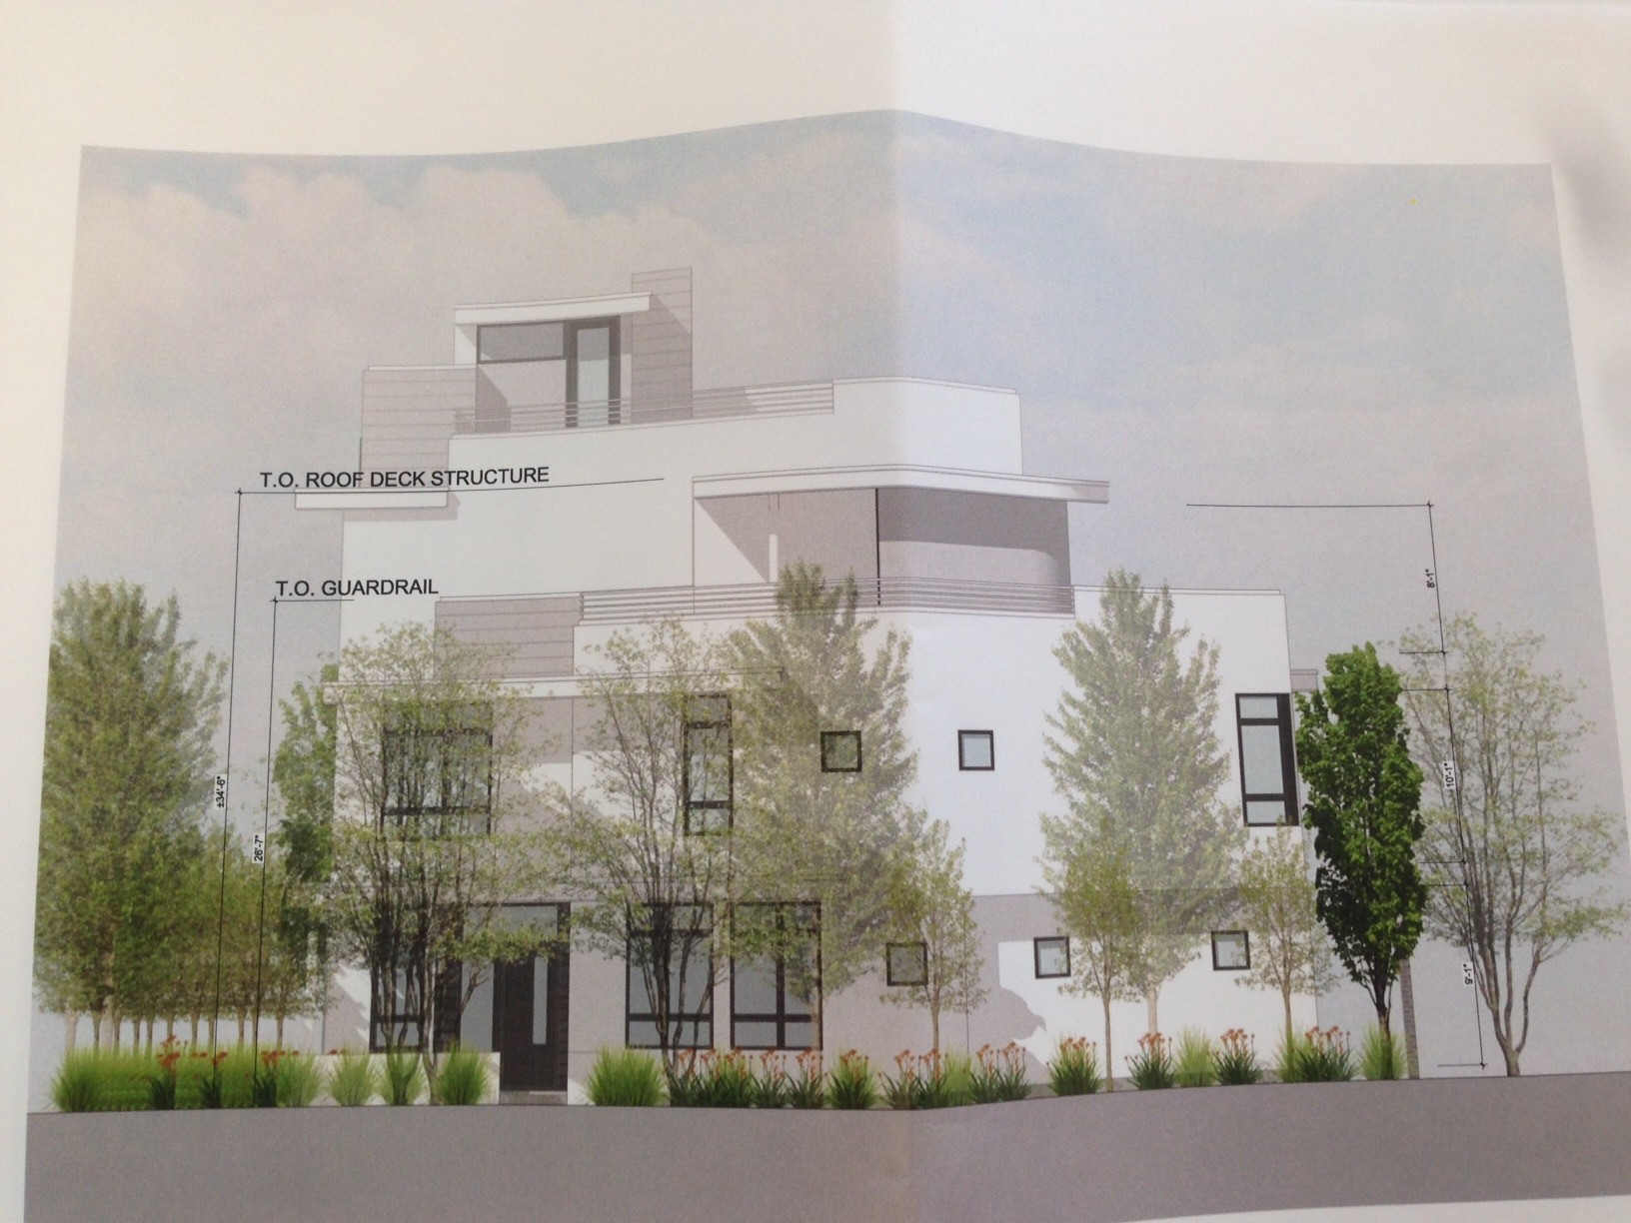This is a proposed small lot subdivision on the current site of a single family home that will be presented at the Mar Vista Planning & Land Use Meeting Tuesday 17th November. All are welcome.

Location of the meeting:

Windward School 11350 Palms Blvd. Meeting Room # 800 Starting 7pm

Property:

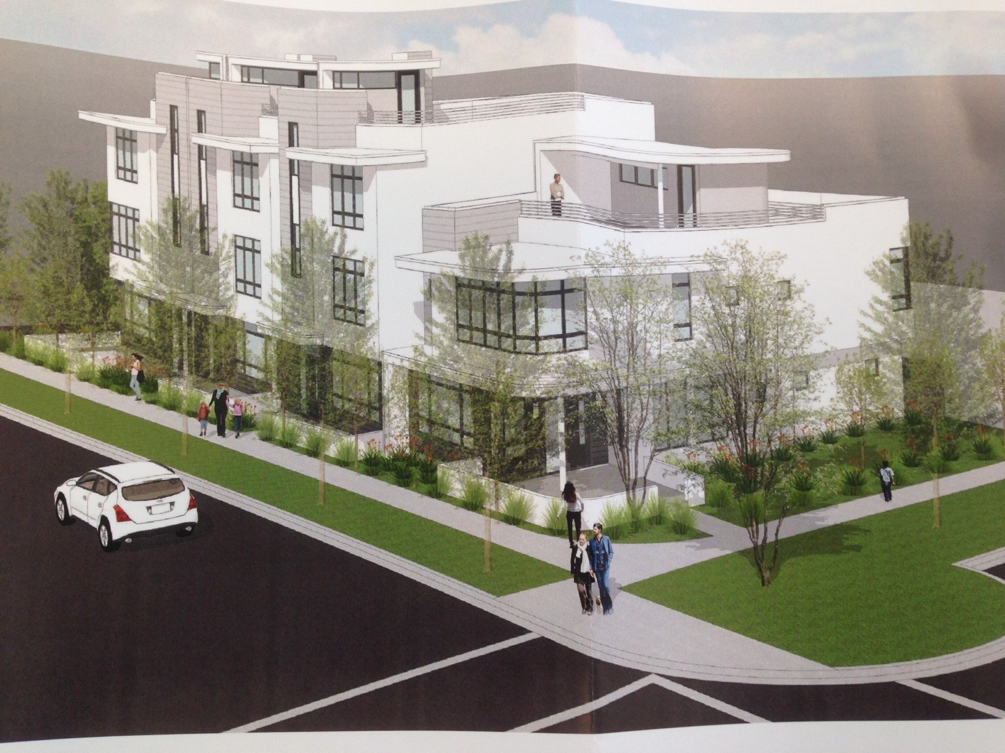7646 sq ft lot size Zoned R3
45 Foot Height Limit Currently a Single Family Home

New Proposal:

4 Single Family Homes Each with:

3 Bedrooms, 2 Car Garage Roof Deck
45 Feet High

Allowable on this R3 Site

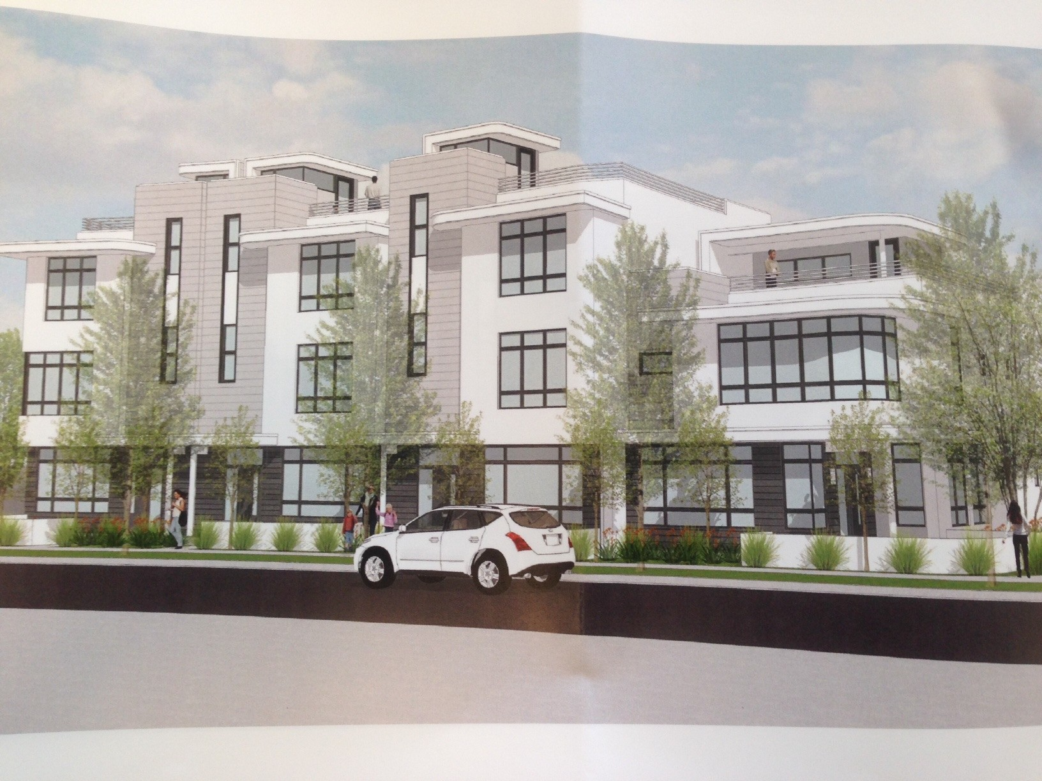1 Home every 800 sq ft 8 apartments are possible

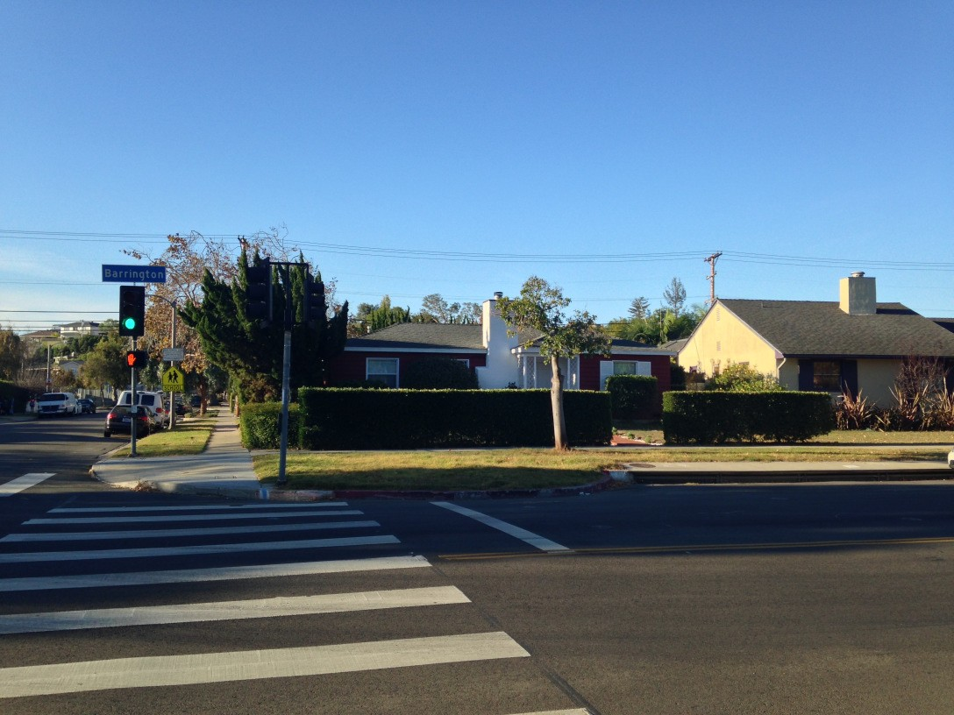
Current home on this property

